Respect Stories
Stories & Illustrations
Bringing Respect to Life
By Young Australians
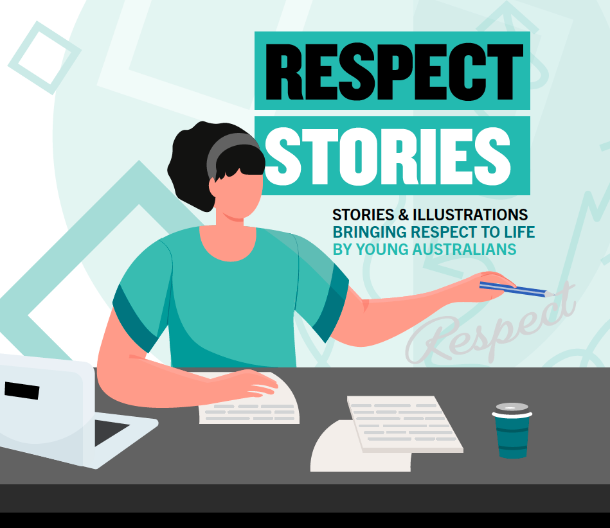
DSS 2775.08.22

This document, Respect Stories, is licensed under the
Creative Commons Attribution
https://creativecommons.org/licenses/by/4.0/legalcode
Notice identifying other material or rights in this publication:
1. Australian Commonwealth Coat of Arms—not Licensed under Creative
Commons, see https://www.pmc.gov.au/government/commonwealth-coat-arms
© Commonwealth of Australia (Department of Social Services, www.dss.gov.au)
DSS 2775.08.22

Respect Stories
Stories & Illustrations
Bringing Respect to Life by Young Australians

Foreword
I started my working life as an officer with the Queensland Police working alongside many different people and dealing with new situations every day. Each life experience has taught me important lessons and skills that I continue to use today—taking time to listen, acknowledging differences and finding ways to work together.
While it can sometimes be hard to find the right words to express how you’re feeling, and to talk about topics that are important to you, it has been heart-warming to see first-hand the many different ways we can think about, show and understand what respect means through the Respect Stories competition.
I have two children and believe that it is important to talk about and role model respect in ways that are meaningful to all of us. This is what I also want for you. To feel safe and supported, and to have the confidence to talk about anything and everything, today and in the future. With small steps, we can make a difference—and move closer to a culture free from disrespect and violence.
Well done to everyone who took part in the competition and congratulations to the 2022 winners.
The Hon Justine Elliot MP
Assistant Minister for Social Services

Table of Contents
Foreword iii
Acknowledgements 1
Acknowledgement of Country 1
Support information 1
About the campaign 2
Resources 2
Illustration Winners 3
Yindyamarra 3
Respect 4
Written Winners 5
The War Witch 5
What is Respect? 7
Respecting Race—For Those Who’ve Come Across the Seas, We’ve Boundless Plains to Share 9
Deepest Respect 13
What respect means to me. 16
Priority access—newly appointed ground force agents Message status: urgent 17
How To Be Respectful 19
Respect 21
Book Blurb 22

Acknowledgements
The national Respect Stories competition was first held in 2022 as part of the Australian Government campaign, Stop it at the Start—Bring up Respect.
Congratulations to the winning writers and illustrators for the time and effort you each took to deliver your personal reflections about what respect means to you.
A special thanks to Maggie Dent and Jo Stanley for taking the time to judge the entries and for their ongoing support of the campaign. We know it wasn’t an easy feat to select winners given the high calibre of entries.
To all who entered the first ever Respect Stories competition, thank you for sharing what respect means to you. We look forward to hearing from you again in the future.
We would also like to thank all the teachers, parents and supporters who helped this year’s entrants submit their work. Every little talk you’ve had about respect has helped to shape their entries and importantly, their understanding of respect.
All of the entries have been transcribed verbatim to honour the true words of the authors.

Acknowledgement of Country
The Department of Social Services acknowledges the Traditional Owners of Country throughout Australia, and their continuing connection to land, water and community. We pay our respects to them and their cultures, and to Elders both past and present.

Support information
1800RESPECT is the national domestic, family and sexual violence counselling, information and support service.
If you or someone you know is experiencing, or at risk of experiencing, domestic, family or sexual violence, call 1800RESPECT on 1800 737 732 or visit 1800RESPECT.org.au in an emergency, call 000.

About the campaign
Stop it at the Start is the national campaign to reduce violence against women and their children. Starting in 2016, the campaign is now in its fourth phase.
The campaign helps to break the cycle of violence by encouraging adults to reflect on their own attitudes, and have conversations about respectful relationships with the young people in their lives.
All adults including parents, grandparents, teachers, coaches, community leaders and employers of young people, play a role in raising a generation of respectful young people and positively influencing how they understand respect.
By taking small, simple steps—such as questioning seemingly harmless comments or jokes, role modelling positive behaviours and having ongoing, proactive conversations about respect—we set the standard for what is and isn’t acceptable.
These steps all help move us closer to a future for our children that is free from disrespect and violence.

Resources
A range of resources and tools are available on the campaign website, www.respect.gov.au, and include:
- The Conversation Guide to help parents and family members talk with young people about the importance of respectful relationships from an early age.
- The Excuse Interpreter to discover the hidden meanings of common expressions that can excuse disrespectful behaviour.
- The Respect Checklist for adults to become more aware of what young people might be thinking about disrespect.
- Generation Respect a guide to help adults build confidence to start conversations with other adults about raising a respectful generation of young people.
Resources are also available for First Nations Australians and people from culturally and linguistically diverse backgrounds at www.respect.gov.au

Illustration Winners

Yindyamarra
Lane, 14
New South Wales
Yindyamarra is the Wiradjuri word for respect and the title of my painting. As a proud Indigenous boy, I believe we need to respect the land, the animals and the many diverse cultures and every individual person that lives here in Australia. We can show respect in many different ways like being kind, using our manners by saying please and thank you, listen to others’ views and ideas and showing empathy towards others.
Last and most importantly yindyamalgirridyu guyunganmadilin (I will respect myself).
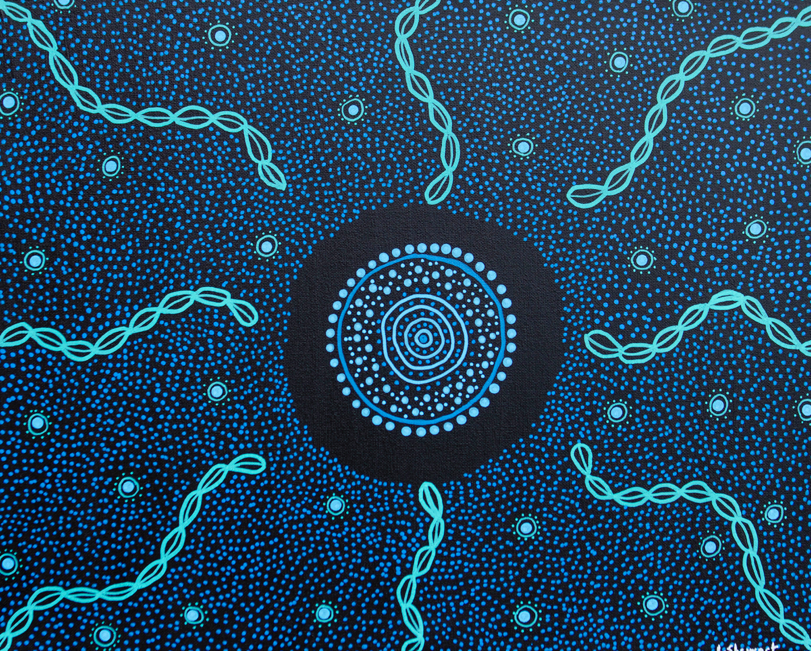
Figure 2 Yindyamarra by Lane, 14 years old

Respect
Olivia, 12
Tasmania
I decided to base my illustration off respect for young women and girls because even though it is something that is getting resolved there is so much more that needs to get done to stop this appalling manner. There are so many young women and girls out there that feel worthless because of the way that they are treated. I want to change the future of respect for all females of the world and make them feel like they belong. No girl or women deserves to be treated so awfully.
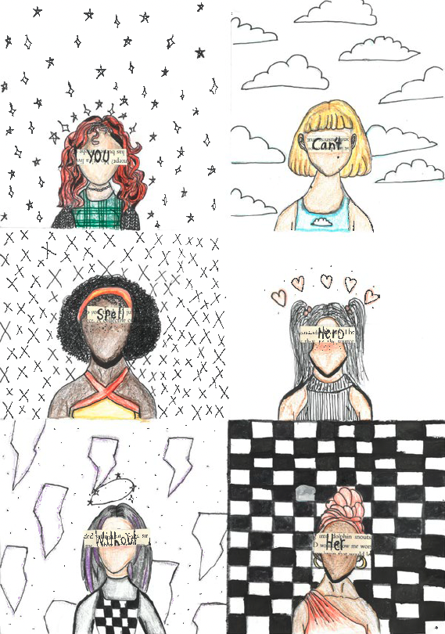
Figure 3 Respect by Olivia, 12 years of age

Written Winners

The War Witch
Ava, 11
Australian Capital Territory
I am 913 steps into my school walk. As I enter the 920s my heart gallops so wildly it could hit my ribs. My throat squeezes shut and I forget to breathe. I feel the same familiar fear sweep over me. Starting above my ponytail, spreading down my spine until it reaches my toes.
I glance down at my toes and I see a shoelace on my worn out school shoe is undone. My fear transforms into panic. I know not to stop in the 960s because it is terrible witch territory. I look down at the concrete path. I know every weed growing through the cracks. I know every patch of rust at the bottom of the fence. I can’t look up.
Step 977 and I am at the corner where I bend down to tie up my lace. My backpack feels heavy and I tip over. I imagine what it would’ve been like to fall in front of the no good nasty witch’s house. She would burst out the creepy black door with the paint peeling off. Her windows have bars and when they are open, frayed curtains look like ghosts trying to escape. There are weeds in the front grass and I heard the school seniors say she uses poisonous plants for her potions. I’ve seen The Witch once. I was walking in the rain. My glasses were foggy but I could see she was beastly. Her hooked nose peeked out from crunchy wild grey hair. Her eyebrows were bushy, her eyes were cloudy and her thin lips barely moved as she screamed something at me.
As I get up with two perfectly tied laces, I feel the morning sun on my cheeks and I stretch. I continue the walk to school with step 978. When I pass another black front door, I remember what Clementine had told me about The Witch. Clem said she has a plump face, a scar that merged into a wrinkle and a fierce black cat. When I realise I am holding my breath again, I distract myself with thoughts of the day ahead until my footsteps feel lighter.
Today is November 11th, Remembrance Day. The winner of the War Hero poetry contest is going to be announced. Before I can think anymore I see the familiar face of Clem across the street and I speed to walk the journey together. A simple side hug and we are on our way, giggling and gossiping. The school bell rings out across the crowded courtyard and a few moments later all students have disappeared into the classrooms as if they were never there at all.
The Remembrance Day Service starts right after recess. Sitting on the hard wooden floors of the grand hall, I push my hips forward and shoulders back. My ankles roll on the floor and I follow the lines of the floorboards all the way to the front of the hall. Red Poppies made in art class are lined up along the front of the stage. I stop counting them when the Principal is introducing the special guest and I lose my place. A local hero who was responsible for saving the lives of many soldiers is the special guest of honour.
As The Principal starts to introduce the local legend, I can hear my blood rushing and a ringing fills my ears. I see The Principal is speaking but I can’t hear a word she is saying. Suddenly everything is silent. I look around and notice everyone bowing their heads. The clock at the back of the stage shows the time is 11.11 am. It is the minute of silence. I take a deep breath, put my feelings to the side and reflect on the bravery and sacrifice of the men and women who fought during the wars. In my reflection I feel respect and I feel thankfulness. I realise that I was once again lost in my thoughts when I looked to the stage feeling shocked at what I saw in front of me.
The Witch is the wartime hero.
I listen to her speak and learn that First Lieutenant Rosemary Beacham of the AANS is one of 25 nurses to receive a military medal for bravery during World War II. She worked in the grimmest of times. She signed up to ‘do her bit’ without question. The hellish hospital First Lieutenant Rosemary Beacham was in charge of had over 3,000 patients in four years and only 75 died. As she describes the night the hospital was raided, for the second time that day, my throat squeezes shut and I forget to breathe. I feel my cheeks get warm and then wet. Tears trickle down my face and land on my school shoes. I felt ashamed of all the things I had thought of her. My shoulders slump over. She isn’t a witch. She doesn’t brew potions. Ghosts aren’t trying to escape from her windows. I didn’t give First Lieutenant Rosemary Beacham the respect she earned and she deserved.
My head snaps back up when I feel an elbow on my ribs. I look to the stage and see people look at me. “Congratulations,” I hear my teacher exclaim somewhere to my right. Without knowing what I was doing I leap to attention and make my way to the stage. I keep my eyes on First Lieutenant Rosemary Beacham, decorated veteran, local hero and non witch. Her eyes are warm and her hand feels soft as she shakes mine. I thank her for her service and she thanks me for writing a patriotic poem.

What is Respect?
Elise, 12
Western Australia
Respect is many things. It can be respecting fellow citizens, i.e., treating others how you wish to be treated, respecting places, i.e., our beautiful Aussie bush, it can be inclusivity to all races, genders, and beliefs. All of these, and more, are crucial to our society. However, to me, the most impactful and important of them all for the youth in these times is self-respect.
Loving yourself is something many people in my generation find hard, if not impossible. A national survey found that an overwhelming 73% of Australian citizens wish they could change something about their appearance. 41.5% of people most of the time or always compare themselves to others on social media. 53.6% of people rarely or never speak positively about their appearance.* Body image issues are becoming increasingly common all over the world. There is an overpowering ‘idealised’ body type being put out all over socials, of girls being skinny and having that flawless ‘hourglass figure’, and guys having a perfect jaw and being super fit.
Recently I’ve gone through a period of not having much appearance related self‑respect. I saw myself as overweight, when I really wasn’t. It affected my life severely, and I was less confident than I had ever been. I experienced constant negative thoughts and saw myself as ‘fat’ and ‘ugly’. I didn’t feel comfortable in my own skin, and I wished, oh I wished, that I could look more like the influencers I saw on social media so often. I never realised that most of those selfies I was seeing had been touched up, and instead I felt guilty to my body and thought I should be doing more exercise and eating less, to be skinnier.
I started watching “prom dress” videos and enjoyed using the dresses as inspiration for drawings and imagining myself in them. As time went on, however, I started ignoring the dresses and focusing more on the girls wearing them. I had thoughts like “they are so much skinnier than me” and “their hair is so shiny and thick” and “I could never look good in that dress”. I didn’t want to tell anyone. I was embarrassed.
In the end it got so bad that I needed to talk to someone, and I finally told my mum. Even after all of the support from my friends and family, I still don’t always feel confident with how I look. I did some research and found out that around 70% of Australian girls and 60% of Australian boys are not happy with their appearance. I felt angry at how many people have to go through this alone. I became passionate about this issue, and I wanted to do something to help. Something to spread awareness for this huge problem, that isn’t recognised for how much of a concern it really is in our country.
I’m not in this competition for the prize. I’m in it for every single person that reads this who understands what I’m talking about. I’m in it so that everyone that reads this thinks about my story and realises how big this really is.
You only have one life. Don’t spend it feeling jealous for photoshopped images of influencers. All bodies are different. All bodies are beautiful. Why should we be defined by how we look? RESPECT YOURSELF.
Bibliography
Statistics sourced from https://butterfly.org.au/news/national-survey-finds-that-more-than-1-in-3-australians-are-unhappy-with-the-way-they-look/

Respecting Race—For Those Who’ve Come Across the Seas, We’ve Boundless Plains to Share
Emma, 14
South Australia
Generally speaking, the world is comprised of a total of approximately 650 cultural and ethnic groups (Fisher, 2013)—of these, a substantial 43%, 278, constitute the population of Australia (ABS, 2019).
As the lyrics of the anthem Advance Australia Fair suggest, multiculturality is a major, significantly distinctive component of the nation:
“For those who’ve come across the seas /
We’ve boundless plains to share /
With courage let us all combine /
To Advance Australia fair.”
The line “With courage let us all combine,” evidently demonstrates the importance of all races within Australia, essentially, collaborating as one, in order “To Advance Australia fair,”; or in simpler terms, assist the development and progress of Australia as a united country. Clearly, a sense of respect between ethnicities is necessary, and should be a given. Despite this, Australia continues to be afflicted by acts of belittlement on the basis of cultural background.
Since 2019, the entire world has been afflicted by the coronavirus disease. Closed national and state borders, social distancing, reminders to sanitise hands, surgical masks; they have all become commonplace daily fixtures. Among the obvious health-related concerns, however, a deep-rooted discrimination against Asian‑Australians has risen to the surface in response to the pandemic.
I, personally, am Korean-Australian. My parents hail from South Korea, having immigrated to Australia, and I was born in the country. My family are considered Australian citizens, earning the citizenship five years ago. I am fortunate enough to have had limited encounters with prejudice and disrespect due to my background, but the two happenings that I can recall both occurred during the pandemic.
First, in mid-2020, at a swimming training, an unfamiliar nine-year-old, likely someone’s younger sibling, looked directly in my eyes, and told me to stay outside of the pool, lest I ‘infect it’ with my ‘COVID germs’.
Second, in late 2021, as I walked onto a public bus, a stranger took note of my mask‑clad face, glared at me pointedly, and proceeded to exit the bus at the next stop.
Of course, these circumstances are laughably minor compared to the severe verbal attacks and physical assaults others have suffered, but they collectively have an aspect in common—neither I, nor any other Asian victims, have ever been at fault. The only existing flaw that led to a lack of respect was that we dared to be born with East Asian features. It is a fact that widespread coronavirus infection may be traced to Wuhan, China; and it is also a fact that a white, mid-thirties American man from Washington state contracted the virus and became the first source of it in the United States. Both sides were not in the wrong, and the point is, ethnicity is a baseless factor for blame.
Additionally, and somewhat paradoxically, as well as the racism prevalent against “…those who’ve come across the seas,” disrespect for the original owners of Australia’s land themselves, the Indigenous Australians, persists.
Late May of 2020 brought about the unjust murder of African-American George Floyd at the hands of Minneapolis police during an arrest, that was largely publicised by means of social media. This incited extensive prominence of a series of movements collectively titled ‘Black Lives Matter (BLM)’, which was originally founded much earlier, that broached imperative issues regarding the prevalence of racism within general everyday circumstances, including g even the official criminal justice system. In Australia, whilst protests were formed in solidarity, parallels could also be drawn from the death of George Floyd by considering authority misconduct and racial prejudice against Indigenous Australians.
65,000 years.
That is the period of time the First Nations people of Australia have occupied its mainland; a number that solidly predates human settlement of even Europe and the Americas (Acton, 2012). Comparatively, the first inklings of colonisation touched on Australia’s shores in the form of Captain Arthur Phillip and an accompanying 1,500 English convicts in merely 1788, and in the decade that followed, the population of Indigenous Australians decreased by 90% (Australians Together, 2022). Despite clear indications of the deserved respect towards the First Nations, a lack of it populates recent history, and continues to do so today.
Yet the moments that respect is provided are the moments that are, and will continue to be, acknowledged widely. For instance, former Prime Minister Kevin Rudd’s 2008 apology speech is a turning point in history. The annual NAIDOC Week, held in July for the past fifty years, honours and celebrates Aboriginal and Torres Strait Islanders’ culture and achievements. Implementation of Asian language courses, such as Chinese, into the Australian Curriculum, contributes to the raising of increasingly respectful, culturally aware generations to come.
The answer to increasing racial respect of any kind lies in two principal factors: education and self-awareness. From a young age, it is essential to incorporate the fight against racism and discrimination, and respect for diversity, into the curriculum. Particularly with the modern rise of ‘cyber-bullying’ and ‘keyboard warriors’, stipulating responsible, respectful uses of the Internet is very relevant.
Additionally, closely monitoring racist occurrences in school environments and adhering to appropriate policies and rules to end them is an important practice. Referring to adults, this concept of education is still applicable—for example, in workplaces, recruitment of employees from minority groups should be encouraged, and all people acting in a position of authority, especially, must be trained to work with people of all backgrounds.
Furthermore, self-awareness acts as the first, personal step for an individual towards anti-racism. Overcoming both conscious and unconscious cultural stereotypes and biases is a significant aspect to becoming mindful of what actions may be perceived racist and offensive. Even having the composure to, upon visiting a home, ask whether shoes should be taken off prior to entering, is a deed representing respect.
Together, through simple acts of respect, we can construct an inclusively diverse Australian society, and in turn, “Advance Australia fair”.
Bibliography
Acton, C. (2012). Evidence of first peoples. Nma.gov.au. [online] doi:https://www.nma.gov.au/definingmoments/ resources/evidence-of-first-peoples. [Accessed 27 Jul. 2022].
Australian Bureau of Statistics ABS. (2019). Australian Standard Classification of Cultural and Ethnic Groups (ASCCEG), 2019. [online] Available at: https://www.abs.gov.au/statistics/classifications/australian-standard-classification-cultural-and-ethnic-groups-ascceg/latestrelease#:~:text=Cultural%20and%20ethnic%20group&text=There%20are%20278%20cultural%20 and,not%20elsewhere%20classified’)%20categories. [Accessed 18 Jul. 2022].
Australians Together. (2022). Colonisation | History Of When Australia Was Colonised. [online] Available at: https://australianstogether.org.au/discover-and-learn/our-history/colonisation#:~:text=In%201788%2C%20Captain%20Arthur%20Phillip,population%20was%20reduced%20by%2090%25.[Accessed 24 Jul. 2022].
Fisher, M. (2013). A revealing map of the world’s most and least ethnically diverse countries. [online]
Washington Post. Available at: https://www.washingtonpost.com/news/worldviews/wp/2013/05/16/a-revealing-map-of-the-worlds-most-and-least-ethnically-diverse-countries/ [Accessed 18 Jul. 2022].

Deepest Respect
Florence, 10
South Australia
Sage Ample dragged her feet along, scuffing them on the pavers. She looked around, slick birds darted cheekily in and out of the Poplar and Elm trees. Sage sighed. Her gaze returned hastily to the ground.
Emmeline Pankhurst tightened her corset, pulling on her maroon dress and tight heels. She quickly did up her hair in delicate curls. She glanced up in the mirror, unsure of whether or not she would succeed.
Sage arrived at her bleak brick school, the school flag was wrapped around its pole, looking like it never wanted to fly again.
Emmeline walked briskly, lifting her feet high. The breeze rustled her cheeks, leaving them red and cold.
Sage approached an old door, it’s paint was peeling off, the doorknob was rusty. Sage gingerly opened it, wondering what horrors would await her.
“There you are!” Exclaimed Emmeline’s friend, Charlotte. “Yes,” muttered Emmeline. She was staring at Charlotte. Charlotte with her perfect curls, perfect smile, teeth. Everything about her was perfect. Was she ready for this?
Mr. Shush sauntered into the classroom, turning on the electric whiteboard. It crackled, sending a message into the room: do not break the rules. Sage sighed.
“There is going to be a lot of rule breaking in this,” Emmeline said. “Yes. There is,” replied Charlotte. The wind around them was brewing up a gale, the scorched autumn leaves that littered the cobbled paths were flying around them. “We must meet the others.”
“Thomas Jefferson was a…” Sage was zoning out. Why listen to what one man had to say about something, when there was the whole world to question? Why did they have to listen to boring lectures and serious people?
Emmeline pointed to a lamppost. “That’s the one,” said Emmeline firmly. “Are you sure?” Questioned Charlotte. “Yes, yes I am.”
“Hey, Sage,” a noise came from behind her desk. Sage’s shoulder’s sagged. The bully. Ricky Ransom. He would go out of his way to make Sage’s life a misery. He was constantly bugging her. Sage turned around.
Emmeline tugged Charlottes arm and Charlotte toppled slightly, but regained balance. They walked towards the lamppost, and sure enough etched onto the middle was, “we are here.” Emmeline and Charlotte turned around.
“Why haven’t you been paying attention, idiot?” Ricky said, his voice was smooth and perfect. Sage’s body shook in anger. “I’m not an idiot!” Sage said, gritting her teeth.
Emmeline’s face twisted into a smile. “Suffragettes, thank you for coming.” Emmeline sniffed. For years she had been shunned aside, drowned in darkness when all she and her fellow women wanted was light!
Ricky smirked. “You are an idiot.” Sage tugged at her shiny brown hair, rubbed her brown nose. She took a deep breath and gripped her textbook until her knuckles turned white. “I’ll show you…” she muttered.
“VOTES FOR WOMEN!” Came the screams. Emmeline thrust her sign into the air, stamping her foot on the ground. Puddles lined the streets, but the women just ran through them at full pelt, splashing water, staining their stockings.
They didn’t care. Yells and shouts of anger were being thrown aground furiously. “Halt!” Came a voice.
Ricky stood up slyly, before saying “Sir, may I go to the toilet?” Mr. Shush smiled, looking at Ricky as if he was an amazing celebrity, of which he was waiting for an autograph. “Yes, you may.” Ricky slowly advanced to Sages’s table. “This is what you get,” he hissed, knocking the books off her table. “Ricky!” She yelled, scrambling to recover her notes and many essays that had been dumped on the floor. “Mister!!!” Wailed Ricky, drastically holding his knee. “Sage HIT me with her books!”
Emmeline was drowned in chains, the shackles biting into her heels and wrists. She was roughly pushed into the back of a horse drawn cart. “Emmeline!” Cried Charlotte, who was being thrown into a different cart. “I’ll find you!” Emmeline promised. But her heart strained with regret. Would she?
Mr. Shush’s eyes bore into her, making her feel uncomfortable and anxious. “I want an essay,” he snapped. “An essay by me tomorrow, about respect. Respecting your teachers. Your peers. Something you can obviously not do.”
Emmeline was thrust into a tiny cage, with a dusty sink and a small bed which had been worn down by many sleepers. Many of which, Emmeline guessed, hadn’t enjoyed it. The paint was peeling sadly off the walls. Emmeline felt like the world was collapsing onto her. “And you can think about respect!” Barked the rude officer, whose moustache jolted along with him every line he spoke. Emmeline grimaced. I’ll never think of your version of RESPECT!
Sage sank into her small, mauve bed. She undid her brown hair, taking pleasure in feeling it flop down next to her. Sage rubbed her forehead. She dropped her hand off her head and onto her chest. She peered down at her hand. A feeling of horror struck her. Her hand was smudged with black. Sage sat bolt upright, before leaping off her bed and peering into her slightly cracked mirror. And sure enough, she saw it. Written in big bold letters. Loser.
Emmeline peered into the water she had cupped in her hands. The water rippled, but she was still able to see her reflection. Her nose was bent awkwardly, her hair had unravelled and was now limp around her face. She sighed. What had she become?
Sage pulled her battered laptop out of her black school bag. She began to type.
Emmeline looked up, spilling the water on the ground. Something stirred in her heart. She closed her eyes.
Respect is not judging. Respect is looking at another side of the story, wondering what life could be like if you were in another’s shoes. Never jumping to conclusions. Never saying you hate someone, but haven’t seen their side of the story. Respect lies within us. We all have it, but some of us must search to find it.
They smiled. Somehow knowing something had been done.

What respect means to me.
Henry, 10
Queensland
Respect is a symbol of kindness. It’s helping anyone who needs help, helping women, helping strangers, helping just because they’re people and they need help.
Respecting women is important because they are people. It doesn’t matter if they are your sister or an important person’s daughter or a famous movie star, they are all people. The same as all of us. And all people deserve to be respected.
Respect is also not discriminating against people because of their skin colour or gender or intellectual intelligence or religion. Just being one nation and being one people.
Every living being deserves respect. Even cows who are going to be killed for their beef still deserve respect when they’re living.
And what about names of things? Like cavemen... there was bound to be cave women, cave children, cave elders, cave teens, and don’t forget the cave tweens! Why were they only known as cave MEN?... it was most likely because girls weren’t allowed to go and study. So only men became palaeontologists, so only they were digging for bones and when they found ancient human skeletons, because of the size of their ego, they probably would have said, “it’s our great manly ancestors, showing us their manly remnants of their great ancient manly kingdom!!”
So why don’t we change that? We can say cave dweller instead of caveman, postie instead of postman, fire fighter instead of fireman, and police officer instead of policeman.
By using -man words, we’re saying women weren’t there or they weren’t important or they don’t matter. But they were there. They are important. They do matter. To respect women, we need to respect them in our words, our hearts and our minds.

Priority access—newly appointed ground force agents
Message status: urgent
Patrick, 10
New South Wales
Greetings agents! I am writing this letter to you from the director themselves with an important message for you to follow. Here at F.R.I.E.N.D (For Respecting Individuals Everywhere Nicely and Diligently), we have worked extremely hard to ensure our agents are vigorously prepared with the tools needed to implement respectful behaviour everywhere and always. As a new recruit, you’ve been given the responsibility to take on this job as an undercover agent. CONGRATS! To make sure you have all the knowledge you need we have equipped you with some critical tools. These include:
- Observant eyes
- A loud voice
- Courage
- Empathetic heart
You must have these tools with you at all times, especially when you’re on the ground. Observant eyes are essential for seeing how people feel and when someone’s behaviour may be impacting another negatively. A loud voice and courage work together to ensure you can stand up and speak up for people when they are being disrespected. An empathetic heart is the most vital tool, letting you know how other people feel and being able to support them if they need it.
These tools will enable you to become an official agent of our organisation F.R.I.E.N.D.
Knowing the different ways you can be an agent in different places is crucial. Here are some of the ground areas.
- School
At school, respectful behaviour can look different in the classroom and the playground. In the classroom, respectful behaviour can include treating your classmates and teachers equally, putting your hand up and not screaming or talking over people and completing your work to the best of your ability. On the playground, you should include others in your games, ensure no one’s hurt and look out for your friends. (This will be a long‑term goal as this mission will go on for 13 years)
- Work
As an agent, you are not only showing respect to the general population but also to your colleagues! Some of the different ways this may look may be, treating everyone the same regardless of agent rank, using equipment for its intended purpose and being supportive of other people. These tips can also be used in other workplaces beyond F.R.I.E.N.D.
- Public transport
Public transport is used by many different types of people. You can be respectful by giving up your seat for someone who needs it more than you, keeping your voice down on buses, trains, light rails and ferries and making sure you pay the right amount of money. Although when standing up for people may be daunting at times, you must do the right thing to make others feel respected. This also includes the bus driver who receives a lot of disrespect.
- Shops
We can be respectful at the shops by waiting our turn in line, giving others things that might be in low supply and thinking carefully about where and why we’re spending our money. What this means is if a company is not showing respectful behaviour, you shouldn’t buy their products.
- Online
It is incredibly easy to disrespect other people online without getting into trouble, as they’re most likely anonymous, but behind every screen is an innocent person, whose feelings are being hurt. Many of the ways our agents can be safe online are by reporting others who are disrespecting you or other people, telling a trusted friend or adult when someone makes you feel uncomfortable, thinking before you press send, being truthful about who you are, keeping your own and others private information to yourself and being thoughtful about the places you visit online.
- Fun zones
Fun zone areas are places such as birthday parties, arcades, bowling centres, chess centres, parks, carnivals and the movies. You can be respectful in fun zone areas by remembering to share and let others have a turn, playing fairly and being patient.
- Cultural events
Every time we begin an important event an Acknowledgement of Country should be said to respect the traditional owners of the land you stand on. This is incredibly important and is a massive part of reconciliation.
- Sport
While sport can be very exciting and competitive, it is important to be aware of what sportsmanship is. You can be respectful by thanking and shaking the other team’s hand, encouraging your teammates and your competitors and not arguing with sports officials.
You are now a fully-inducted member into the F.R.I.E.N.D force. Make sure you use your tools wisely and be a friend to all those around you wherever you may be.

How To Be Respectful
Rebecca, 12
New South Wales
The images became a quick glimmer. Long continuous hours of aimless yet compulsive scrolling. You’d see people pressuring each other, people harassing others for their opinion, people getting teased over things they could not control. Past me would have been scared, horrified at what I was seeing, but the more you see it, the more you grow unfazed to these types of things, keeping silent and scrolling endlessly once more. Just another person on the internet.
It was one of those days, one of those seemingly never ending scrolling sessions before I slammed my phone onto my table as each blink stung slightly. I stared at my clock that sat alone on my shelf. 9:28. It read, though I read it as two hours from the start of my long scrolling session. It shocked me how much time had passed, but at the same time, it was a repetitive habit, so rather, I was surprised by the fact it had happened again. Sluggishly, I rolled out of my chair and unsteadily got onto my feet as cramps clutched onto my stiff muscles. While I wasn’t necessarily feeling the worst when I got up, after two hours of non-stop screen time, a nice walk would do no harm. I pulled on a pair of slate grey sneakers that I reserved only for the occasional walk. I contemplated changing my clothes, but a lilac tunic with baby blue sweatpants didn’t seem like the most embarrassing outfit. With a gush of fresh air filling my lungs, I stepped outside. To begin my journey.
***
I didn’t know how long I had been walking for. The sun glazed my skin a light shade of red as I tried to search for a bus stop or at the very least, someone who knew where one was. The foreign neighbourhood overwhelmed my eyes as more unfamiliar houses grew into sight. I had noticed the theme of lush pine green hedges and blooming roses being repeated across the street of houses, each sharing similar characteristics while still having its own individual flair. Then one garden caught my eye. The garden overflowed with a mellow flora scent that filled the garden with an engulfing sense of relaxation, enchanting blossoms of peonies opening their mouths gracefully as if they were a prized trophy. Standing within its flourishing foliage stood a man.
“Excuse me,” my voice was soft as I gave a small smile to the man. “Do you know where I can find a bus stop?”
The man squinted his beady amber eyes into my face with an attitude as if he was disappointed with a feature of my face. He tutted his head angrily and furrowed his thick caterpillar eyebrows over.
“Asians,” he muttered under his breath, curling his lips back. “No, cannot help.”
I felt my external mood suddenly gloom but I still held a smile on my face. While race wasn’t the nicest thing to bring up, who knows what he’s gone through.
“Alright, thank you. Have a nice day.”
As I let out an exasperated sigh, a sudden blue vehicle caught my eye. A bus! It took a sharp turn before coming to a halt by a tall pole. Frantically, I crossed at a yellow crossing, mouthed a quick sorry to the onlooking cars and tapped on my Opal card as I took a seat at the back of the bus. Of course, my phone was already magically sitting snugly in my palm as the bus proceeded to move.
“Imagine being a girl. They’re so weak.” The utter pride and amusement in the person’s voice over their remark caught my attention. There were three boys sitting together and a girl sitting alone in the seat opposite, all no older than thirteen.
“Ew, look at her. She’s wearing a dress,” another boy mocked. That was the final straw that lit my burning flame.
“Leave her alone!” my voice bellowed above the chatter of the bus. The two boys turned their heads swiftly and glanced at me, mirroring gazes of confusion. I pushed their looks aside and continued. “Just because she’s a girl doesn’t mean you get to make fun of her about it. You’re being extremely disrespectful. How would you feel if I started teasing you because you’re a boy?”
I paused as I heard a chime as my suburb echoed on the speaker. “Gladesville!”
“Think about it,” I ended as the boys sulked their heads.
She tapped my shoulder. “Thanks for standing up to them.”
“Hey,” I placed a hand on her shoulder. “No-one deserves to be treated that way, especially over something you can’t control. They were being disrespectful, and it’s not your fault.”
She gave off a pitiful smile like she knew it was all pathetic, like it would happen again. Would it, would it happen again? Before I knew it, I was standing alone in an empty street. Unease slithered through my body, not because I was lost, no, I knew these streets, but because of what I had just witnessed. Thoughts plagued my mind, each word just another start for another unanswered, intensely frightening question.
What would have happened if I wasn’t there to stop them?
How many people have copied their behaviour?
How many people have experienced being treated like that?
But then I came to the place so familiar, the place I had lived at for so, so long. It stood there, unchanged, its walls glazed in trophies of time yet holding the same fresh look as the first time I saw it. In some ways, I saw myself. Distinctly unchanged while the environment and everything else had. Too long had I stayed silent, too long had I stayed complacent to horrific behaviour and supported its toxic environment. I opened my social media account, not to mindlessly scroll, but I was going to change it, not just so that girl could smile whole heartedly, but for everyone.
As I began its title: How To Be Respectful

Respect
Kha, 11
Victoria
Respect, respect
Don’t you forget
You need it because
It has big effect
Use your manners
Say please and thank you
If you’re nice to people
They show respect too
Being kind is a must
Helping others in need
It’ll make you feel good
This small little deed
Treat others as equals
Don’t think you are more
We all are the same
Deep down in our core
Listen to others
Do not look away
Do not interrupt
Everyone wants their say
Do not be selfish
Share with others
They want it too
Just as much as you
Live up to your word
Don’t say and not do
If you want others to do it
You need to do it too
Respect is something that needs to be learnt
You must give, before it’s returned
You need to respect all the others
Your friends, your sisters, and your brothers
Your peers, your teachers, and strangers too
All needs respect coming from you

Book Blurb
The Respect Stories competition was first launched in 2022 as part of the Australian Government campaign Stop it at the Start—Bring up Respect.
The written pieces and illustrations within this book were created by students 10–14 years of age. The judges were author, comedian and advocate Jo Stanley, and one of Australia’s favourite parenting authors and educators, Maggie Dent.
“I have been inspired and deeply moved by the collection of entries in Respect Stories. While they are so varied in their telling, they all show a sophisticated understanding of what respect is. They’re also wonderfully creative and share some precious, personal perspectives that beautifully connect us, the audience, with the message. Well done! Brilliant work!”
JO STANLEY—CEO, Broad Radio
“The entries were indeed varied and full of passion and insight and I thoroughly enjoyed reading and viewing them all. Thank you for the honour and privilege of being a judge.”
MAGGIE DENT—Author, Parenting & Resilience Educator

