POST COPY | AUDIENCE | BANNER
Entries are now open for the #RespectStories competition!  If you know a young person aged 10-14, they can win great prizes by sharing what respect means to them!  Entries can be a drawing, poem, short story or essay up to 1,000 words and winners will receive $500 for themselves and $500 for their school.  Winning entries will also be published in a national storybook.  Find out more today www.respect.gov.au/RespectStories.  #BringUpRespect #StopItAtTheStart | Parents, teachers and influencers | Respect Stories Competition Banner 4 – boy on computer  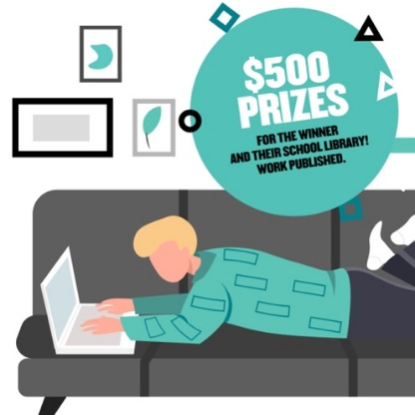
Have you heard about the #RespectStories competition?  If you’re 10-14 years old, you can win some great prizes by sharing about what respect means to you!  Submit a drawing, poem, short story or essay of up to 1,000 words and be in the running to win $500 for yourself and $500 for your school. Winning entries will also be published in a national storybook.  Entries are open now! Find out how to enter at www.respect.gov.au/RespectStories.  #BringUpRespect #StopItAtTheStart | Students | Respect Stories Competition Banner 2 – typing boy  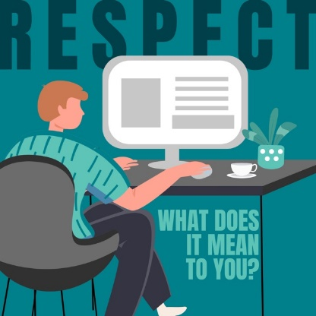
Entries for the #RespectStories competition are closing soon!  This competition offers the chance for young people aged 10-14 to win $500 for themselves and $500 for their school library.  All they have to do is enter a piece of writing of up to 1,000 words or draw a picture on the topic of RESPECT.  Entries are open until 11:59pm Sunday 14 August 2022 (AEST).  Winners will also have their work published in a national storybook.  To find out more visit www.respect.gov.au/RespectStories  #BringUpRespect #StopItAtTheStart | Parents, students and influencers | Respect Stories Competition Banner 3 – girl on phone  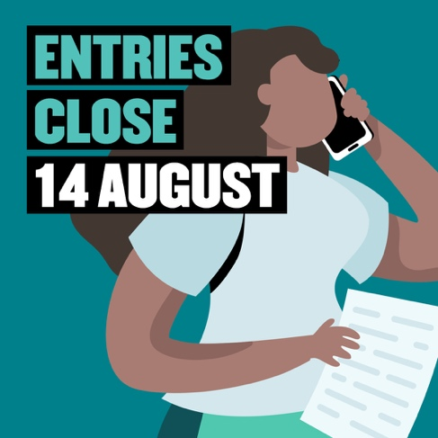
Entries for the #RespectStories competition are closing soon!  Are you between 10-14 years old? Don’t miss your chance to be published in a national storybook, as well as winning $500 for yourself and $500 for your school.  All you have to do is enter a piece of writing of up to 1,000 words or an illustration about what respect means to YOU!  Entries are open until 11:59pm Sunday 14 August 2022 (AEST).  To enter now visit www.respect.gov.au/RespectStories  #BringUpRespect #StopItAtTheStart | Students | Respect Stories Competition Banner 1 – writing girl  