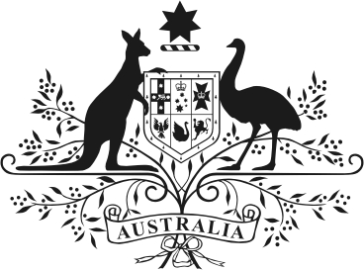

SENATOR THE HON ANNE RUSTON
Minister for Families and Social Services
Manager of Government Business in the Senate

MEDIA RELEASE

EMBARGOED 12.01am 8 March 2021

Australians encouraged to “unmute” themselves and call out disrespect

The Morrison Government will today launch the $18.8 million third phase of the national campaign to reduce violence against women and their children to mark International Women’s Day.

The Stop it at the Start campaign encourages adults to “unmute” themselves and empowers them to take actions that will have a positive influence on the attitudes and behaviours of young people.

Minister for Families and Social Services Anne Ruston said the campaign was critical in our efforts to prevent family, domestic and sexual violence.

“Each and every one of us has a role to play in ensuring disrespectful attitudes and behaviours towards women are not learned in childhood,” Minister Ruston said.

“By launching the next phase of Stop it at the Start on International Women’s Day we are sending a powerful message about the role we all must play to ensure all women can fulfil their potential.

“We all need to unmute ourselves when we witness disrespect and turn it into an opportunity to set the standard for what is and isn’t acceptable.

“Taking action on this issue may seem overwhelming but if we all take small steps, such as reconsidering our own views or talking to our children about respectful relationships, it can add up to a positive change for Australia.”

The Stop it at the Start campaign began in 2016 as an initiative under the National Plan to Reduce Violence Against Women and their Children 2010-2022.

It is jointly funded by Commonwealth and the governments of South Australia, the Australian Capital Territory, the Northern Territory and Tasmania.

Evaluation research found the campaign was changing attitudes with 42 per cent of adults taking action such as having a conversation with a young person about respectful relationships or changing the way they behave towards others as a result of previous phases of the campaign.

The first phase encouraged adults to recognise their own unconscious behaviour and understand its influence then phase two asked people to take ownership of the issue rather than using arguments to rationalise disrespectful behaviours.

Phase three of the campaign will be rolled out across television, cinema, online, outdoor, digital and social media from Sunday 14 March.

In addition, a suite of tools and resources will be available online at www.respect.gov.au to help parents and other adults to model positive behaviours and start a conversation about respect with the young people in their lives.

Minister Ruston thanked the Commonwealth Bank for partnering with the Morrison Government to deliver the launch event where a panel discussion would canvass how government, business and the broader community must come together to address the issue of violence against women.

If you or someone you know is impacted by sexual assault, domestic or family violence, call 1800RESPECT on 1800 737 732 or visit www.1800RESPECT.org.au.

Note to media: Broadcast-quality television commercials and high-resolution versions of other advertisements are available at https://www.respect.gov.au/the-campaign/media/

ENDS

Media contact:
Sheradyn Holderhead 0418 514 271 | Sheradyn.Holderhead@dss.gov.au
Genevieve Morris 0467 950 884 | Genevieve.morris@dss.gov.au

